Name: Divyansh Dubey

Roll no: 231070001

Course: DAA

Program: B. Tech Computer Engineering 2nd year

Batch: A

**Assignment- 2**

**Aim:** Write an algorithm for Linear Search and Binary Search.  
Write a program to solve given problem using your algorithms. Apply coding style in your programs.

Algorithm:

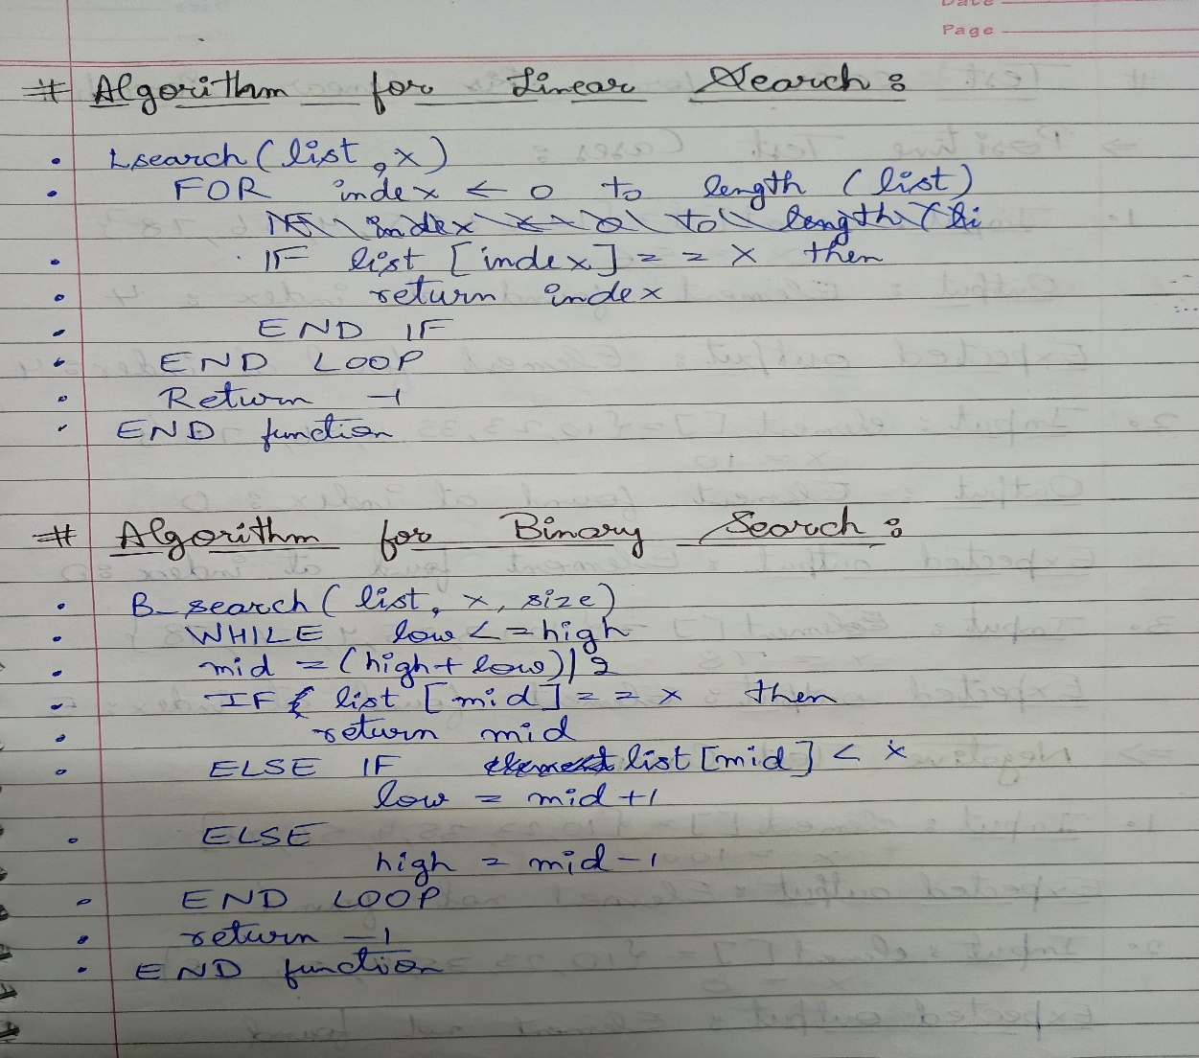

Test Cases:

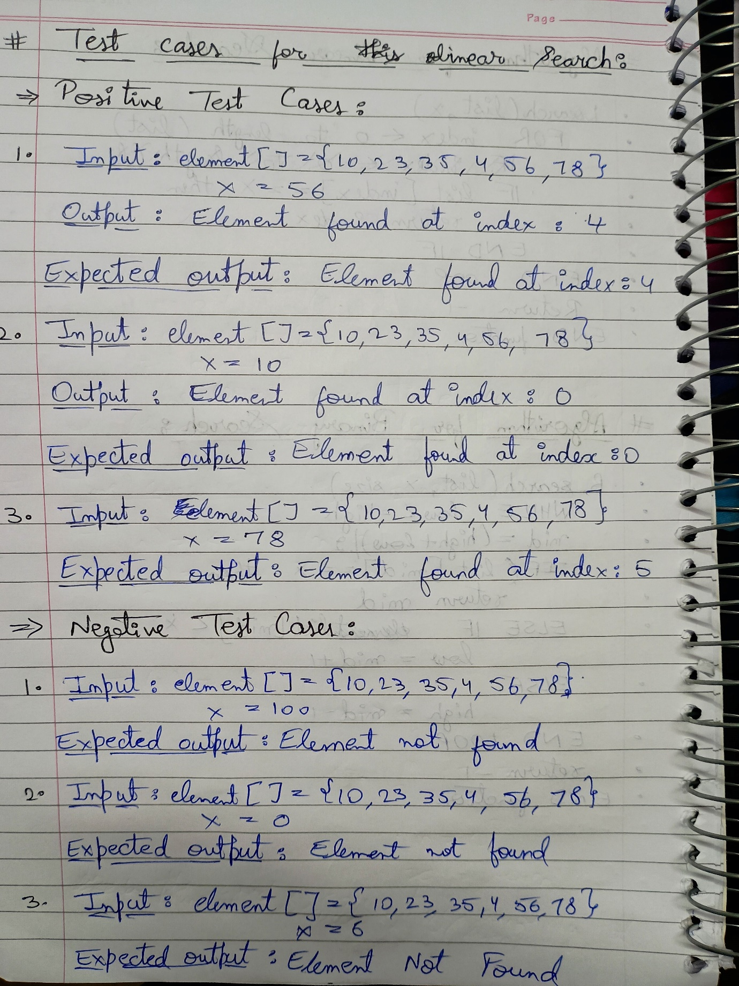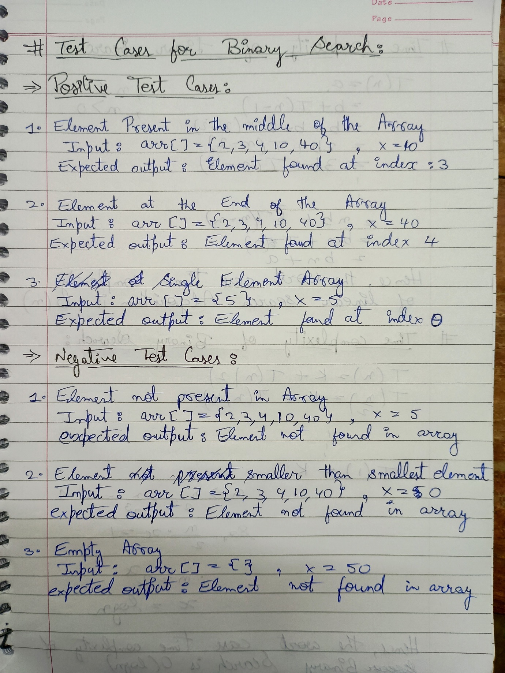

Time Complexity:

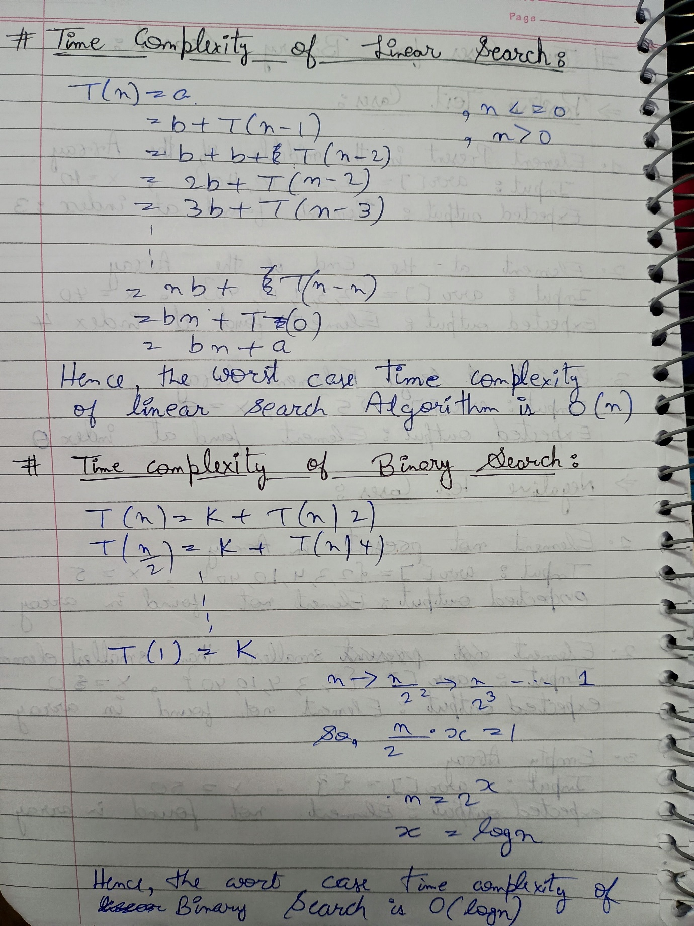

Program:

Linear search:

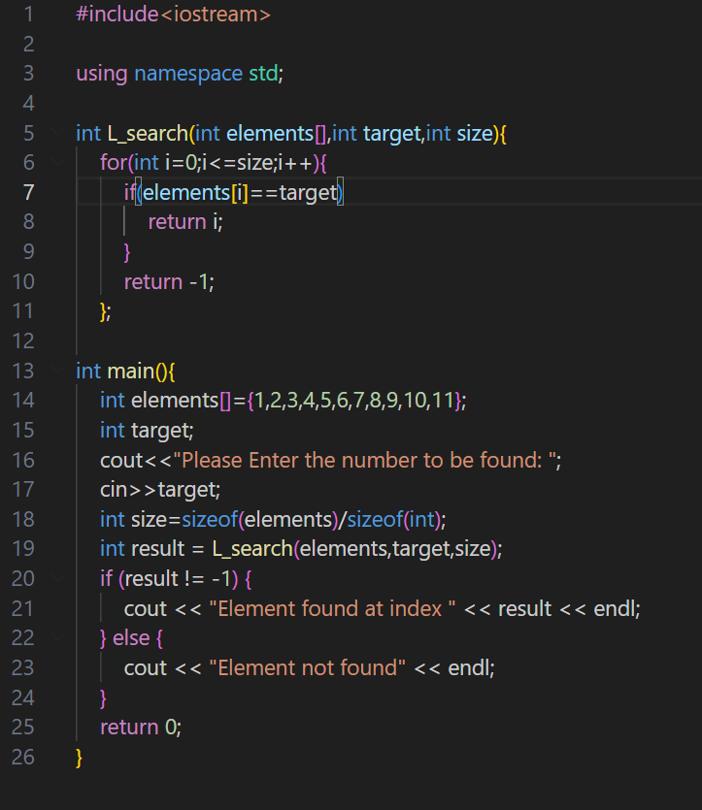

Output:

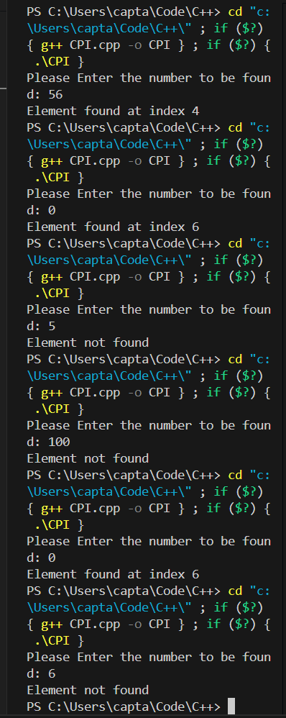 ` 1

Binary search:

Output:

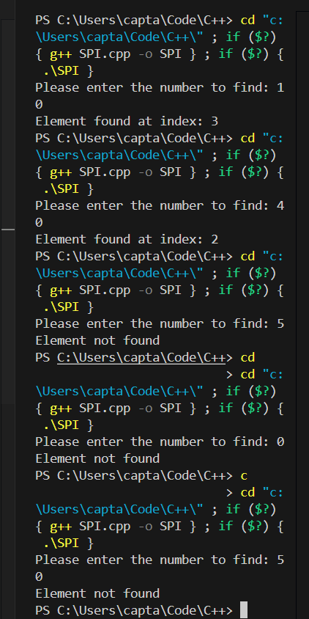

Conclusion: Linear and binary search are two important algorithms to search any element from any set of data regardless is it sorted or not. Their time complexity differs a lot. Linear can search from sorted and unsorted data both with worst time complexity of O(n) whereas binary seach is much more time efficient with worst time complexity of O(log n) but works on sorted set of data only. Also, we can check their different test case scenario having different inputs with variying output statements.